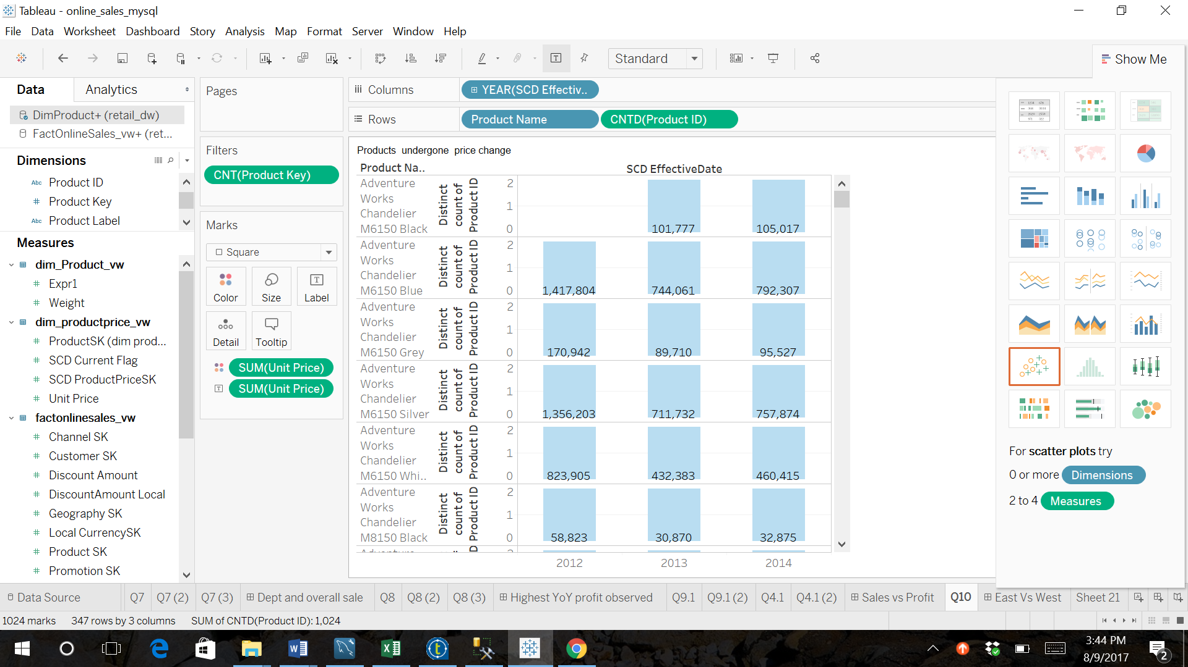

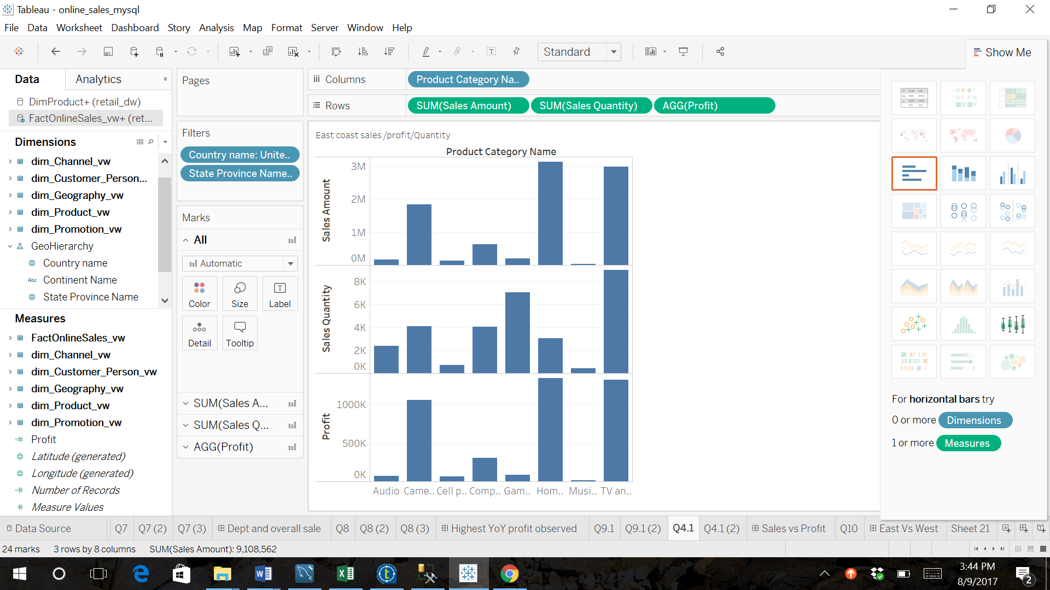

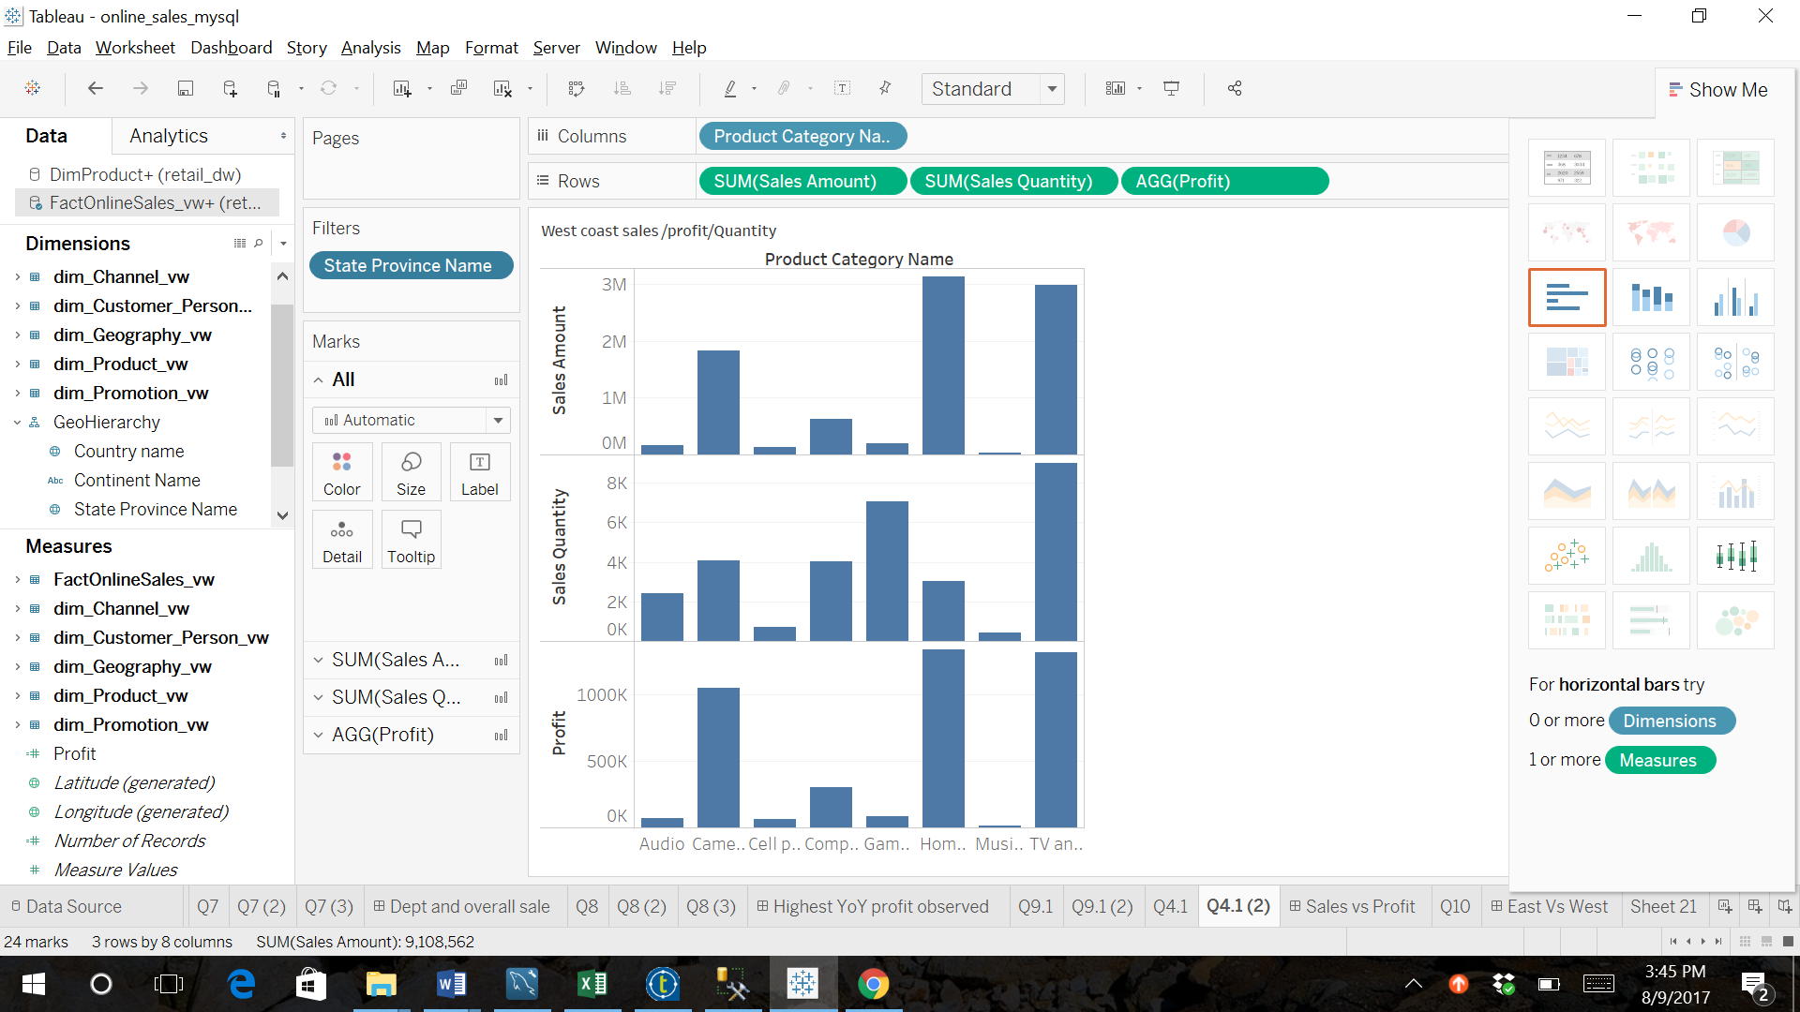

use retail_dw;

CREATE VIEW dim_Channel_vw

AS

SELECT ChannelSK, ChannelKey, ChannelLabel, ChannelName, ChannelDescription

FROM DimChannel;

CREATE VIEW dim_Customer_Person_vw

AS

SELECT CustomerSK, CustomerID, CustomerLabel, CustomerKey, GeographySK, Title, FirstName, LastName

FROM DimCustomer_Person;

CREATE VIEW dim_date_vw

AS

SELECT DateSK, FullDateAK, FullDateTimeAK, YearID, MonthID, DayID, YearMonth, YearQtr, DayOfYear, WeekOfYear, DayofWeek, MonthAbr, DayAbr, MonthFull, DayFull, FullDateUSA, DayOfMonth, DaySuffix, DayName,

DayOfWeekUSA, DayOfWeekInMonth, DayOfWeekInYear, DayOfQuarter, DayOfYearChar, WeekOfMonth, WeekOfQuarter, WeekOfYearChar, MonthChar, MonthName, MonthOfQuarter, Quarter, QuarterName,

YearChar, YearName, MonthYear

FROM DimDate;

CREATE VIEW dim_Entity_vw

AS

SELECT EntitySK, EntityKey, EntityLabel, ParentEntityLabel, EntityName, EntityDescription, EntityType, StartDate, EndDate, StartDateSK, EndDateSK, Status

FROM DimEntity;

CREATE VIEW dim_Geography_vw

AS

SELECT GeographySK, GeographyKey, GeographyType, ContinentName, Country, Country_name, RegionCountryName, Region, StateProvinceName, Subdiv_name, City,

CityName

FROM DimGeography;

CREATE VIEW dim_Product_vw

AS

SELECT ProductSK AS Expr1, ProductKey, Product_ID, Brand_ID, ProductLabel, ProductName, ProductDescription, ProductSubcategoryKey, ProductSubcategoryLabel, ProductSubcategoryName,

ProductSubcategoryDescription, ProductCategoryKey, ProductCategoryLabel, ProductCategoryName, ProductCategoryDescription, BrandName,

StockTypeName, AvailableForSaleDate, StopSaleDate,

Status

FROM DimProduct;

CREATE VIEW dim_ProductPrice_vw

AS

SELECT SCD_ProductPriceSK, ProductSK, CurrencyKey, UnitPrice, SCD_EffectiveDate, SCD_IneffectiveDate, SCD_Current_Flag

FROM DimProductPrice;

CREATE VIEW dim_Promotion_vw

AS

SELECT PromotionSK, PromotionID, PromotionKey, PromotionLabel, PromotionName, PromotionDescription, DiscountPercent, PromotionType, PromotionCategory

FROM DimPromotion;

CREATE VIEW dim_SalesTerritory_vw

AS

SELECT SalesTerritorySK, SalesTerritoryKey, GeographySK, SalesTerritoryLabel, SalesTerritoryName, SalesTerritoryRegion, SalesTerritoryCountry, SalesTerritoryGroup,

StartDate, EndDate, Status

FROM DimSalesTerritory;

CREATE VIEW dim_Scenario_vw

AS

SELECT ScenarioSK, ScenarioKey, ScenarioLabel, ScenarioName, ScenarioDescription

FROM DimScenario;

CREATE VIEW dim_Store_vw

AS

SELECT StoreSK, StoreID, StoreKey, SalesTerritorySK, StoreManager, StoreType, StoreName, StoreDescription,

GeographySK

FROM DimStore;

Create view DimCustomer_vw

as

SELECT

CustomerSK

,CustomerID

,CustomerKey

,CustomerLabel

,'Person' as CustomerType

,GeographySK

,case when MiddleName is not null then LastName+', '+FirstName+' '+MiddleName

else LastName+', '+FirstName

end as CustomerName

FROM DimCustomer_Person

union

SELECT

c. CustomerSK

,c.CustomerID

,c.CustomerKey

,c.CustomerLabel

,c.CustomerType

,c.GeographySK

,c.CompanyName as CustomerName

FROM DimCustomer_Company c;

create view DimMonth_Plan_vw

as

SELECT YearID*100 + MonthID as PlanMonthSK,

DateSK as PlanDateSK,

FullDateAK as PlanDate,

FullDateTimeAK as PlanDateTime,

YearID,

YearQtr as QuarterSK,

(YearQtr - (YearID*100)) as QtrID,

MonthID,

MonthAbr,

MonthOfQuarter

FROM DimDate

where DayOfMonth = 1

and YearMonth >= 201201

and YearMonth < 201501;

create view DimMonth_Quota_vw

as

SELECT YearMonth as QuotaMonthSK,

DateSK as QuotaDateSK,

FullDateAK as QuotaDate,

FullDateTimeAK,

YearID,

YearQtr,

Quarter

MonthID,

MonthAbr,

MonthOfQuarter

FROM DimDate

where DayOfMonth = 1

and YearMonth >= 201201

and YearMonth < 201501;

CREATE VIEW FactInventory_vw

AS

SELECT InventorySK, InventoryDateSK, InventoryDate, StoreSK, ProductSK, GeographySK, OnHandQuantity, OnOrderQuantity, SafetyStockQuantity, MinDayInStock, DaysInStock, MaxDayInStock, Aging

FROM FactInventory;

CREATE VIEW FactOnlineSales_vw

AS

SELECT SalesSK, SalesDateSK, SalesDate, CustomerSK, ChannelSK, StoreSK, ProductSK, PromotionSK, GeographySK, SalesOrderNumber, SalesOrderLineNumber, SalesQuantity, ReturnQuantity, SalesAmount,

ReturnAmount, DiscountAmount, TotalCost, Local_CurrencySK, SalesAmount_Local, ReturnAmount_Local, DiscountAmount_Local, TotalCost_Local

FROM dbo.FactOnlineSales;

CREATE VIEW FactSales_vw

AS

SELECT SalesSK, SalesDateSK, SalesDate, ChannelSK, StoreSK, ProductSK, PromotionSK, GeographySK, SalesQuantity, ReturnQuantity, SalesAmount, ReturnAmount, DiscountAmount, TotalCost, Local_CurrencySK,

SalesAmount_Local, ReturnAmount_Local, DiscountAmount_Local, TotalCost_Local

FROM FactSales;

CREATE VIEW FactSalesQuota_vw

AS

SELECT SalesQuotaSK, SalesQuotaKey, ChannelSK, StoreSK, ProductSK, QuotaDateSK, QuotaDateKey, CurrencySK, ScenarioSK, SalesQuantityQuota, GrossMarginPct, Local_CurrencySK,

SalesAmountQuota_Local

FROM FactSalesQuota;

CREATE VIEW FactStrategyPlan_vw

AS

SELECT StrategyPlanSK, PlanDateSK, PlanDatekey, EntitySK, ScenarioSK, AccountSK, ProductCategoryKey, PlanAmount

FROM FactStrategyPlan;

CREATE VIEW V_ProductForecast

AS

SELECT D.MonthID, P.ProductCategoryName, SUM(S.SalesQuantity)

AS SalesQuantity, SUM(S.SalesAmount) AS SalesAmount

FROM FactOnlineSales AS S INNER JOIN

DimProduct AS P ON S.ProductSK = P.ProductSK

INNER JOIN

DimDate AS D ON S.SalesDateSK= D.DateSK

Group by D.MonthID,P.ProductCategoryName